CHAPTER 4: Chemical patterns
Worksheet 4.2

Elements and atomic numbers
Student: Class:

Atomic numbers and mass numbers
1. Each element is characterised by its atomic number (Z). The atoms of an element may not be identical, however, because elements can exist as isotopes. Isotopes have different numbers of neutrons and are distinguished by their mass numbers (A).
Elements can be represented by the following notation:
 | Z = atomic number = number of protons  A = mass number = number of protons plus neutrons
For example, the common isotope of iron has 26 protons and a mass number of 56. The number of neutrons is therefore: 56 – 26 = 30 neutrons.
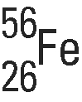
Complete the following table.
Element | Protons | Atomic number (Z) | Neutrons | Mass number (A) | Symbol for isotope
Magnesium (Mg) | 12 |  | 12
Potassium (K) | 19 |  |  | 39
Uranium (U) | 92 |  |  | 238
Technetium (Tc) | 43 |  |  | 99
Beryllium (Be) |  | 4 | 5

Atomic weight of an element
2. The atomic weight of an element is sometimes referred to as its relative atomic mass. The atomic weight is the average or weighted mean of the isotopes of that element, taking into account the relative amounts of each type of isotope. Thus, atomic weights are often not whole numbers.
The periodic table of elements shows the following information for boron (B).
 | 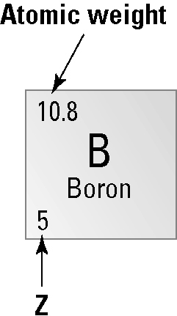 | (a) How many protons are present in the boron nucleus?  (b) Boron consists of two different isotopic forms: boron-10 (B) and boron-11 (B). Compare the number of neutrons in each isotope.  (c) In natural boron, which isotope is more abundant? Explain.

